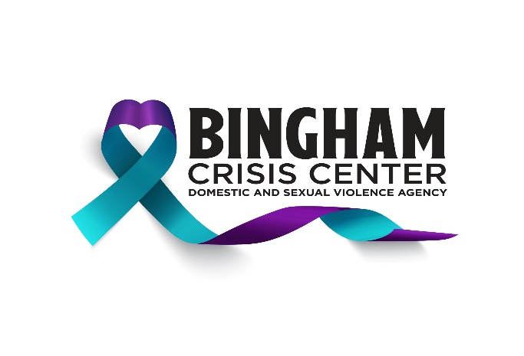
288 N. Shilling Avenue, Blackfoot, Idaho 83221
Phone (208) 785-1047 • Fax (208) 785-7201
Needs List
New Items, Non-expired, and unopened items only please

- Nonperishable Foods
- Easy Meals: mac and cheese, soup, Hamburger Helper, etc.
- Blankets
- New Pillows
- New Sheets/Bedding (Twin, Full, and Queen)
- New Bath Towels
- Kitchen Utensils
- Can Openers
- Pots, Pans, Plates
- Women’s and girls' Underwear- all sizes
- Boys' and Men's Underwear- all sizes
- Gas Cards (for individuals to travel for safety)
- Food Cards (for those in shelter or traveling for safety)
- Laundry Gift Cards
- Storage Totes with Lids

